Contact: Brittany Henry  DPA Headquarters  Phone: 800-652-7826  Fax: 513-794-3342  Email:bhenry@DPABuyingGroup.com | Address:  9200 Montgomery Rd.  Bldg. C, Suite 11A  Cincinnati, Ohio 45242 | Distributor Partners of America (DPA)
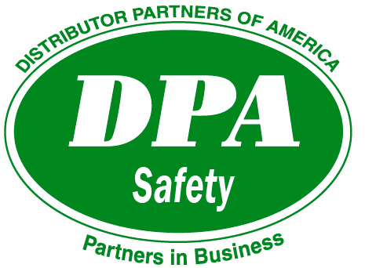
Press Release 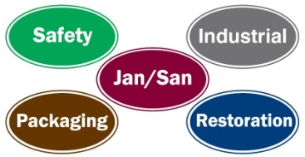

DPA Safety Recognizes 5-year Member Milestones
DPA Safety recognized its 5-year members at its 2015 buying and networking conference in Myrtle Beach, SC. Seven distributor companies were honored with a special 5-year lapel pin at the group’s opening meeting. “These distributors are an important part of the success of DPA's Safety division and we thank them for their tremendous support and dedication to the group,” said Zachary T. Haines, DPA Executive Director.

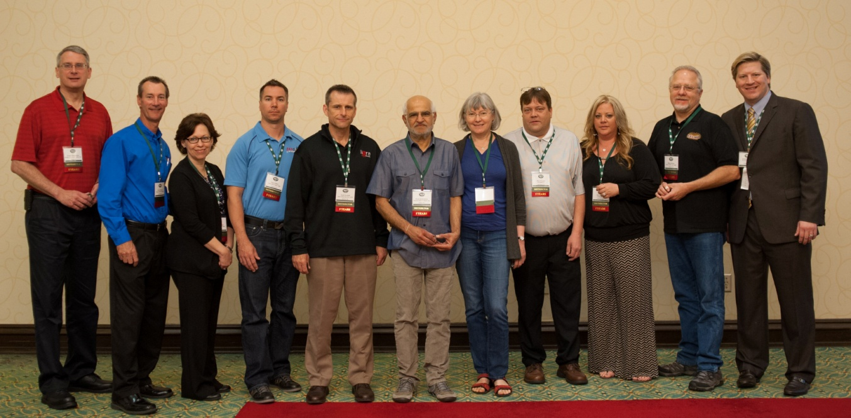
Pictured Above (L to R):
Quality First Aid & Safety, Inc. (Wixom, MI)
Meiners Medical & Safety (Louisville, KY)
First Aid & Safety 2000 (Aurora, CO)
Libra Industries, Inc. of MI (Jackson, MI)
Western Safety Products, Inc. (Seattle, WA)
SJ Smith Co. (Davenport, IA)
Becker Safety and Supply (Windsor, CO)

