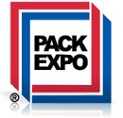
SNEAK PEEK
Pack Expo 2013
September 23 - 25
Las Vegas, NV
Please stop by booth # 6038

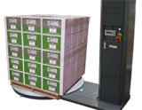 |  |  | New Deal at Pack Expo  Evolution Wrapper the value priced semi automatic stretch wrapper. This workhorse will give you years of trouble free operation. Evolution solves the problems of poorly hand wrapped pallets.  Ask about free Evolution with film deal
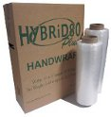 | At PackExpo  HYBRiD80 Plus (Engineered Film) Lighter weight rolls are easier to use and cost less without a loss in performance. This unique film is working and strong right off the roll. HYBRiD 80 Plus is engineered to eliminate the need to stretch film to get maximum performance.
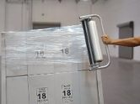 |  | New Demo at PackExpo  Litewrapper allows users to wrap pallets with one hand while safely walking forward around the pallet.  Lighter weight rolls are easier to use and cost less without a loss in performance  NEW! Now coreless to save even more.  Ask about free Litewrapper with film deal

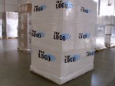 | Logo Film reduces pilferage and improve load appearance. Print with websites, logos, instructions or custom message.  Standard hand and hi-performance machine grade films.  New! Now available in HYRiD80 Plus formula for even more savings.  PackExpo Show Special - Free upgrade to premium white film

Latest on stretch film pricing in the U.S. Click here
More details contact your Western Plastics representative
For more information about Western Plastics click here

Temecula, CA  (800) 442-9727  (951) 695-1983 | Calhoun, GA  (800) 752-4106  (706) 625-5260 | Mississauga, ONT  (800) 957-8886  (905) 568-9999

